LGB Policy and the Geography of Immigrants in Same-Sex Couples in the United States

Same-sex marriage and Migration Workshop in Amsterdam

Nathan I. Hoffmann, Department of Sociology, UCLA

Kristopher Velasco, Department of Sociology, Princeton University

August 27, 2024

Abstract

How do queer immigrants decide where to settle? The policy landscape for same-sex couples in the United States has changed rapidly in recent years, with immigrants being particularly affected. After the 2013 end of the Defense of Marriage Act, U.S. citizens could finally sponsor the visa of a same-sex partner. As previous work of ours has shown, in the wake of this policy change there has been a rapid increase of immigrants in same-sex couples, at least for those from progressive countries (Hoffmann & Velasco 2024). But little is known about where these immigrants choose to settle and enjoy their new rights. Do they gravitate toward queer-friendly cities and states, or are they more concerned with job opportunities or cost of living? How have these patterns changed over time, especially in response to local policy changes relevant to queer people and immigrants? Using American Community Survey data from 2008-2022, this paper will implement descriptive analyses and conditional logit models to study how settlement patterns of immigrants in same-sex couples in the U.S. respond to local and national policy changes as well as other local factors. These geographic measures will include the Human Rights Campaign’s Municipal Equality Index, Velasco’s LGBT Policy Index for U.S. states, and a host of other local measures such as housing prices, average income, queer density, and prevalence of immigrants from the same national origins.

# Introduction

In 2013, the U.S. Supreme Court overturned the Defense of Marriage Act and required the U.S. government to begin recognizing marriages between same-sex spouses. Among many consequences, this decision radically changed the immigration landscape: For the first time, same-sex spouses of U.S. citizens and lawful permanent residents were eligible to file a spousal petition for an immigrant visa (Edwards 2013). In the years since, the U.S. population of lesbian, gay, and bisexual (LGB) immigrants has grown rapidly. As Hoffmann and Velasco (2024) show, numbers of different-sex couples containing immigrants increased by 22 percent from 2008 to 2019 (from 7.8 million to 9.5 million), while those of corresponding same-sex couples grew by 140 percent in the same period (from 44 thousand to 107 thousand). Furthermore, Hoffmann and Velasco (2023) show that, compared to immigrants in different-sex couples, those in same-sex couples come from richer, more democratic, and more LGB-friendly countries that are less represented by immigrants in the U.S. They also tend to be more highly educated, work in more prestigious occupations, and have higher incomes. Hence, despite previous queer migration scholarship largely focusing on asylum seekers and others escaping repressive contexts, these migrants appear to be among the most well-off immigrants in the U.S.

Despite this work, little is known on *where* LGB migrants tend to settle after they arrive in the U.S. In the wake of the DOMA decision, where do these immigrants choose to settle and enjoy their new rights? Do they gravitate toward queer-friendly cities and states, or are they more concerned with job opportunities or cost of living? How have these patterns changed over time, especially in response to local policy changes relevant to queer people and immigrants? Using American Community Survey data from 2008-2022, this paper implements descriptive analyses and regression analyses to study how settlement patterns of immigrants in same-sex couples in the U.S. respond to local and national policy changes as well as other local factors.

# Background

# Data and Methods

Our main source of data is the American Community Survey for 2008 to 2022 (except for 2020, when data quality was not good) (Ruggles et al. 2021). Each year, the ACS surveys a 1-percent representative sample of U.S. households about their education, occupation, income, family structure, immigration status, country of origin, location, and a variety of other individual and household attributes. We define a same-sex couple as two individuals of the same sex in the same household who report their relationship as “spouse” or “unmarried partner.” We limit the sample to individuals age 18 to 64, and immigrants in the sample migrated at the age of 18 or older.

We consider the spatial distribution of three groups: immigrants in same-sex couples, immigrants in different-sex couples, and individuals in same-sex couples where neither individual is an immigrant. The 14 years of survey data contain XX cases.

We use “LGB” to refer to all individuals who may be in romantic relationships with members of the same sex, although we recognize that some individuals in same-sex relationships may not identify as lesbian, gay, or bisexual. We also recognize that we are not able to identify bisexual (or pansexual, multisexual, etc.) individuals cohabiting with different-sex partners. Furthermore, measuring the prevalence of same-sex couples in the U.S. is difficult (Michaels 2013). As in most nationally representative demographic work on same-sex couples (Baumle 2013; Baumle and Dreon 2019), we are able to identify only LGB couples that cohabit; unpartnered LGB individuals and those who do not live with their partner are not included in the analysis (Baumle, Compton, and Poston 2009, 6). In addition, LGB individuals who do not feel comfortable with the partner labels of the ACS are not in the sample. Another pitfall is measurement error: Misreporting may result when different-sex couples accidentally misspecify the gender of one of the partners (Gates and Steinberger 2009; Goodnature and Neto 2021). Beginning in 2008, the Census Bureau made changes to ACS gender and partnership questions in order to prevent such errors (U.S. Census Bureau 2013), so we rely on data only from 2008 onward, but difficulties remain. If even a small number of different-sex couples misreport one partner’s sex, the counts of same-sex couples will be inflated. Following Gates and Steinberger (2009), we remove all respondents that had either their relationship or sex variable allocated by the Census Bureau, which results in dropping XX immigrants in same-sex couples and XX in different-sex couples, or XX percent of the sample. This is the strategy used by most studies of same-sex couples in the ACS (e.g. Boertien and Vignoli 2019; Gates 2013; Goldberg and Conron 2021; Christafore and Leguizamon 2019; Martell and Nash 2020). In Section C of the Online Appendix we include robustness checks to test the sensitivity of our results to hypothetically high rates of misreporting.

## Analytic Strategy

Many of our analyses entail descriptive statistics of ACS data. For these and for the reshaping described below, we apply survey weights from the ACS.

One of our goals is to isolate the effect of country-of-origin LGB policy on the immigration of immigrants in same-sex couples. The ideal survey would follow potential immigrants over time and have information about sexual orientation, allowing us to estimate how the probability of migrating and choice of U.S. state of residence vary by sexual orientation. This ideal dataset does not exist, but we attempt to approximate it.

We reshape the data so that each observation is the percentage of individual cohabiting immigrants in same-sex couples from country $x$ in state $y$ in survey year $z$

## Variables

Most of our variables come from the ACS and are calculated at the level of the Public Use Microdata Area (PUMA), a unit of analysis that includes at least 100,000.

We also use data from two other sources. First, to examine LGB policies at state of destination, we use original datasets. To create the U.S. state policy index, we compile data from the Movement Advancement Project[1], a leading LGB organization in the U.S. that collects data on a number of relevant policies. Our state index encompasses both progressive policies (full marriage equality, state recognition of civil unions and domestic partnerships, ban on all employment and housing discrimination based on sexual orientation, hate crime protections based on sexual orientation, legal joint adoption by same-sex couples, and a ban on conversation therapy for minors) and regressive policies (criminalization of sodomy, state constitutional bans of marriage equality, religious freedom exemptions to discriminate against same-sex couples in adoption, and state-level bans on local non-discrimination ordinances encompassing sexual orientation). The state index ranges from XX to XX, and the mean state policy score for immigrants in our sample is XX.

Our second outside data source is a measure of the prevalence of LGBT nonprofits in a given PUMA. These come from complete IRS data on nonprofits.

# Results

## Descriptive Results

To show broadly how the geography of immigrants in same-sex couples has changed over the past 15 years, Figure 1 presents the percentage coupled immigrants in eage state who are in same-sex couples and how these figures have changed over time. The figure shows maps for three time periods: 2008-2012, 2013-2017, and 2018-2022. Most states had greater proportions of immigrants in same-sex couples in 2022 than in 2008. In addition, the pattern of growth is meaningful. Shortly after the end of the Defense of Marriage Act in 2013, their growth was concentrated in the Northeast, where states were relatively early adopters of same-sex marriage, including Massachusetts (2004), Connecticut (2008), Vermont (2009), New Hampshire (2010), New York (2011), Maine (2012), and Maryland (2013). However, in the next period (2018-2022), more of the map shows higher percentages of immigrants in same-sex couples, including more relatively conservative states.

Table 1 prevents descriptive statistics for PUMA-level characteristics, separated by the three groups of interest: immigrants in different-sex couples, immigrants in same-sex couples, and non-immigrants partnered with same-sex non-immigrants. In the table, all variables are averaged over the full range of survey years. Figures 2 and 3 present the same statistics over time. Immigrants in same- and different-sex couples are similar on a number of attributes. They live in areas with similar proportions of immigrants and Hispanic people, they live in areas with higher home values and rent, and they live in denser areas. They also bear some similarities to non-immigrants in same-sex couples, with similar values of

However, immigrants in same-sex couples live in areas with somewhat more advantage than the other two groups. They live in areas with higher incomes and higher occupational prestige. In addition, the home and rent prices of their areas are somewhat higher than those of immigrants more broadly. They also live in denser areas.

Clear differences also arise around the number of nonprofits in their areas. On average, immigrants in same-sex couples live in PUMAs with 1.2 LGBT nonprofits, while LGB non-immigrants live in PUMAs with 0.76 and immigrants in different-sex couples with 0.30. They also live in areas with more immigrant nonprofits, with an average of 1.0. Surprisingly, the number of immigrant nonprofits for the average immigrant in a different-sex couple and average non-immigrant in a same sex couple are quite similar, at about 0.8.

Figures 2 and 3 show how these differences are fairly stable over time. One notable change is the average percent of Black residents in the typical area for each group: Around 2010, immigrants in same-sex couples were 1 to 2 percentage points more likely to live in areas with Black respondents than the other groups, but in recent years the numbers are very similar.

## Models

Table 2 presents OLS regressions for the percentage of immigrants in same-sex couples, out of all immigrants in couples, at the PUMA level. Model 1 does not include fixed effects, Model 2 includes state fixed effects and errors clustered at the state level, and Model 3 includes both state and year fixed effects and clusters errors at the state and year levels. Model 3 shows that a number of factors remain significant even in models with these fixed effects. Areas are more likely to have higher proportions of immigrants in same-sex couples if fewer people own their own home, if the percentage of immigrants is lower, if more people are over the poverty line, if homes are worth somewhat less, if the density is lower, and if the number of LGBT nonprofits is higher.

Table 3 presents corresponding regressions for the proportion of all people in same-sex couples who are immigrants. Again, a number of coefficients are significant in Model 3, which includes state and year fixed effects. LGB immigrants tend to live in areas with lower income, higher percentages of immigrants, lower unemployment, lower rent, and higher density than LGB non-immigrants.

# Discussion and Conclusion

# References

Baumle, Amanda K., ed. 2013. *International Handbook on the Demography of Sexuality*. Vol. 5. International Handbooks of Population. Dordrecht: Springer Netherlands. <https://doi.org/10.1007/978-94-007-5512-3>.

Baumle, Amanda K., D’Lane Compton, and Dudley L. Poston. 2009. *Same-Sex Partners: The Social Demography of Sexual Orientation*. SUNY Press.

Baumle, Amanda K., and Ben Dreon. 2019. “The Demography of Sexuality.” In *Handbook of Population*, edited by Dudley L. Poston Jr., 279–88. Handbooks of Sociology and Social Research. Cham: Springer International Publishing. <https://doi.org/10.1007/978-3-030-10910-3_11>.

Boertien, Diederik, and Daniele Vignoli. 2019. “Legalizing Same-Sex Marriage Matters for the Subjective Well-Being of Individuals in Same-Sex Unions.” *Demography* 56 (6): 2109–21.

Christafore, David, and Susane Leguizamon. 2019. “Taste-Based Discrimination, Tolerance and the Wage Gap: When Does Economic Freedom Help Gay Men?” *Kyklos : Jahrbuch Des Instituts für Geschichte Der Medizin an Der Universität Leipzig* 72 (3): 426–45. <https://doi.org/10.1111/kykl.12206>.

Edwards, Benjamin P. 2013. “Welcoming a Post-DOMA World: Same-Sex Spousal Petitions and Other Post-Windsor Immigration Implications.” *Family Law Quarterly* 47 (2): 173–89.

Gates, Gary J. 2013. “LGBT Adult Immigrants in the United States.” UCLA: The Williams Institute.

Gates, Gary J., and Michael D. Steinberger. 2009. “Same-Sex Unmarried Partner Couples in the American Community Survey: The Role of Misreporting, Miscoding and Misallocation.” In *Annual Meetings of the Population Association of America, Detroit, MI*.

Goldberg, Shoshana K., and Kerith J. Conron. 2021. “LGBT Adult Immigrants in the United States.” UCLA: The Williams Institute.

Goodnature, Mia, and Amir B. Ferreira Neto. 2021. “Same-Sex Unmarried Partners in the Census.” *Journal of Regional Analysis & Policy* 51 (1): 43–66.

Hoffmann, Nathan I., and Kristopher Velasco. 2023. “Sexuality, Migration, and LGB Policy: A Portrait of Immigrants in Same-Sex Couples in the United States.” *International Migration Review*, August, 01979183231187623. <https://doi.org/10.1177/01979183231187623>.

———. 2024. “Policy Effects on Mixed-Citizenship, Same-Sex Unions: A Triple-Difference Analysis.” *Social Forces* 102 (3): 1134–56. <https://doi.org/10.1093/sf/soad108>.

Martell, Michael E., and Peyton Nash. 2020. “For Love and Money? Earnings and Marriage Among Same-Sex Couples.” *Journal of Labor Research* 41 (3): 260–94. <https://doi.org/10.1007/s12122-020-09305-4>.

Michaels, Stuart. 2013. “Sexual Behavior and Practices: Data and Measurement.” In *International Handbook on the Demography of Sexuality*, 11–20. Springer.

Ruggles, Steven, Sarah Flood, Sophia Foster, Ronald Goeken, Jose Pacas, Megan Schouweiler, and Matthew Sobek. 2021. “IPUMS USA: Version 11.0 American Community Survey 2008-2019.” Minneapolis, MN: IPUMS.

U.S. Census Bureau. 2013. “Frequently Asked Questions About Same-Sex Couple Households.” U.S. Census Bureau Fertility and Family Statistics Branch.

# Tables

Table 1: Mean values for geographic variables for immigrants in different- or same-sex couples, 2008-2022

| Variable | Different-sex, immigrant | Same-sex, immigrant | Same-sex, non-immigrant |
| --- | --- | --- | --- |
| Bachelor's degree (%) | 22.73 | 25.4 | 23.53 |
| Black (%) | 12.60 | 12.9 | 12.75 |
| Hispanic (%) | 24.49 | 23.6 | 16.62 |
| Mean personal income | 27.48 | 29.5 | 27.93 |
| Individuals own home (%) | 61.25 | 58.6 | 62.82 |
| Mean age | 37.71 | 38.4 | 38.48 |
| Immigrant (%) | 20.44 | 20.0 | 13.47 |
| Individuals under 100% of poverty line (%) | 12.62 | 12.4 | 12.23 |
| Individuals under 200% of poverty line (%) | 29.77 | 28.8 | 28.63 |
| Mean HWSEI occupation score | 36.97 | 37.7 | 37.29 |
| Unemployed (%) | 2.63 | 2.5 | 2.44 |
| Mean individual's value of home ($1000s) | 4,111.50 | 4,398.7 | 3,938.43 |
| Mean individual's rent | 406.61 | 481.7 | 363.84 |
| Mean cost of electricity | 2,181.30 | 2,237.4 | 2,200.92 |
| Density (persons per sq. mile) | 8,144.18 | 11,628.1 | 6,088.93 |
| Number of LGBT nonprofits | 0.30 | 1.2 | 0.76 |
| Number of immigrant nonprofits | 0.79 | 1.0 | 0.82 |

Table 2: Proportion of immigrants in same-sex couples by PUMA, regressed on PUMA-level factors

|  |  |  |  |
| --- | --- | --- | --- |
|  | (1) | (2) | (3) |
| Bachelor's degree (%) | -0.005 | 0.011 | 0.011 |
|  | (0.003) | (0.010) | (0.010) |
| Black (%) | -0.001 | -0.002 | -0.002 |
|  | (0.001) | (0.002) | (0.002) |
| Hispanic (%) | 0.001 | 0.001 | 0.001 |
|  | (0.001) | (0.001) | (0.001) |
| Log mean personal income | -0.231 * | -0.212 | -0.197 |
|  | (0.090) | (0.183) | (0.172) |
| Individuals own home (%) | -0.034 *** | -0.043 ** | -0.044 ** |
|  | (0.010) | (0.017) | (0.016) |
| Mean age | 0.057 *** | 0.037 ** | 0.036 * |
|  | (0.003) | (0.014) | (0.014) |
| Immigrant (%) | -0.017 *** | -0.026 *** | -0.026 *** |
|  | (0.001) | (0.005) | (0.005) |
| Individuals under 200% of poverty line (%) | 0.012 *** | 0.014 *** | 0.014 *** |
|  | (0.002) | (0.004) | (0.003) |
| Mean HWSEI occupation score | 0.056 *** | 0.021 | 0.021 |
|  | (0.009) | (0.024) | (0.023) |
| Unemployed (%) | 0.028 *** | -0.007 | -0.006 |
|  | (0.007) | (0.018) | (0.019) |
| Mean individual's value of home ($1000s) | -0.000 ** | -0.000 * | -0.000 * |
|  | (0.000) | (0.000) | (0.000) |
| Mean individual's rent | 0.001 *** | 0.001 * | 0.001 * |
|  | (0.000) | (0.000) | (0.000) |
| Mean cost of electricity | -0.000 ** | -0.000 | -0.000 |
|  | (0.000) | (0.000) | (0.000) |
| Density (persons per sq. mile) | 0.000 * | -0.000 *** | -0.000 *** |
|  | (0.000) | (0.000) | (0.000) |
| State LGB policy score | 0.040 *** | 0.006 | 0.002 |
|  | (0.003) | (0.007) | (0.008) |
| Number of LGBT nonprofits | 0.198 *** | 0.185 *** | 0.185 *** |
|  | (0.005) | (0.044) | (0.047) |
| Number of immigrant nonprofits | -0.026 *** | -0.018 † | -0.018 |
|  | (0.005) | (0.009) | (0.013) |
| State FEs and clustered errors? | no | yes | yes |
| Year FEs and clustered errors? | no | no | yes |
| Observations | 332911 | 332911 | 332911 |
| *** p < 0.001; ** p < 0.01; * p < 0.05; † p < 0.1. | | | |

Table 3: Proportion of same-sex partnered people who are immigrants by PUMA, regressed on PUMA-level factors

|  |  |  |  |
| --- | --- | --- | --- |
|  | (1) | (2) | (3) |
| Bachelor's degree (%) | -0.182 *** | 0.029 | 0.027 |
|  | (0.020) | (0.100) | (0.098) |
| Black (%) | 0.034 *** | 0.027 | 0.027 |
|  | (0.004) | (0.030) | (0.032) |
| Hispanic (%) | 0.044 *** | 0.032 | 0.031 |
|  | (0.004) | (0.022) | (0.024) |
| Log mean personal income | -6.466 *** | -8.474 ** | -8.413 * |
|  | (0.554) | (3.275) | (3.499) |
| Individuals own home (%) | 0.431 *** | 0.391 | 0.389 |
|  | (0.058) | (0.220) | (0.223) |
| Mean age | 0.238 *** | 0.036 | 0.034 |
|  | (0.020) | (0.143) | (0.148) |
| Immigrant (%) | 0.556 *** | 0.470 *** | 0.470 *** |
|  | (0.007) | (0.084) | (0.078) |
| Individuals under 200% of poverty line (%) | -0.042 *** | -0.022 | -0.022 |
|  | (0.012) | (0.036) | (0.039) |
| Mean HWSEI occupation score | 0.647 *** | 0.286 | 0.286 |
|  | (0.052) | (0.347) | (0.331) |
| Unemployed (%) | 0.190 *** | -0.337 * | -0.330 |
|  | (0.043) | (0.142) | (0.171) |
| Mean individual's value of home ($1000s) | 0.004 *** | 0.003 | 0.003 |
|  | (0.001) | (0.002) | (0.002) |
| Mean individual's rent | -0.005 *** | -0.006 * | -0.006 * |
|  | (0.001) | (0.003) | (0.003) |
| Mean cost of electricity | -0.001 *** | -0.001 | -0.001 |
|  | (0.000) | (0.000) | (0.000) |
| Density (persons per sq. mile) | 0.000 *** | 0.000 *** | 0.000 *** |
|  | (0.000) | (0.000) | (0.000) |
| State LGB policy score | 0.515 *** | 0.007 | -0.009 |
|  | (0.016) | (0.138) | (0.054) |
| Number of LGBT nonprofits | -0.205 *** | -0.217 | -0.216 |
|  | (0.031) | (0.153) | (0.147) |
| Number of immigrant nonprofits | 0.053 | 0.112 | 0.112 |
|  | (0.030) | (0.115) | (0.109) |
| State FEs and clustered errors? | no | yes | yes |
| Year FEs and clustered errors? | no | no | yes |
| Observations | 295468 | 295468 | 295468 |
| *** p < 0.001; ** p < 0.01; * p < 0.05. | | | |

# Figures

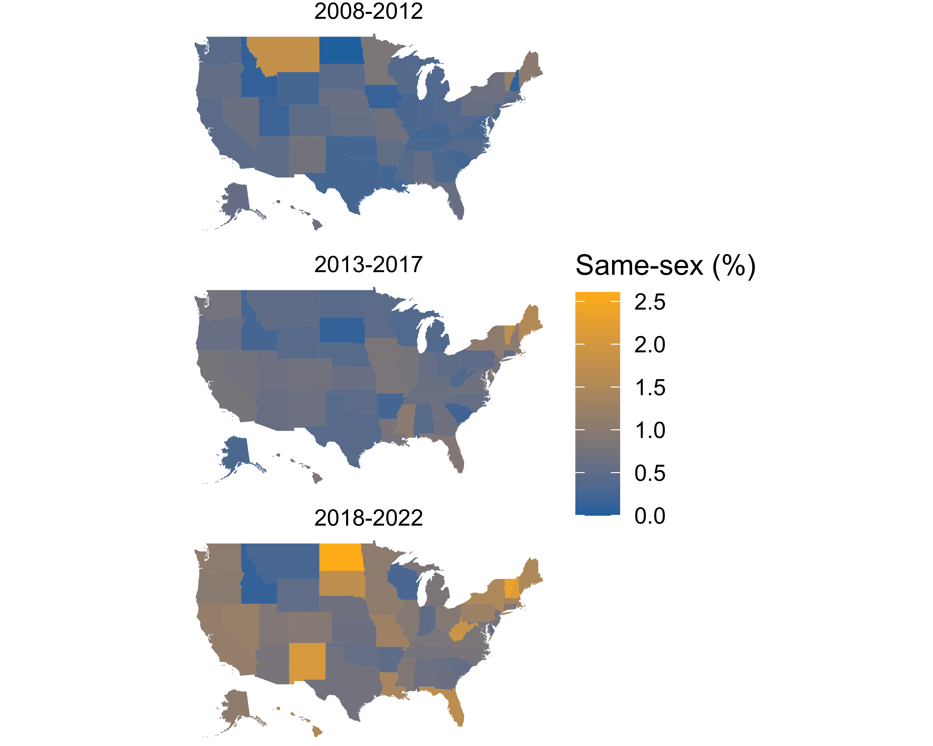

Figure 1: Percentage of cohabiting immigrants in same-sex couples in U.S. states, averaging over ACS survey years 2008 to 2022.

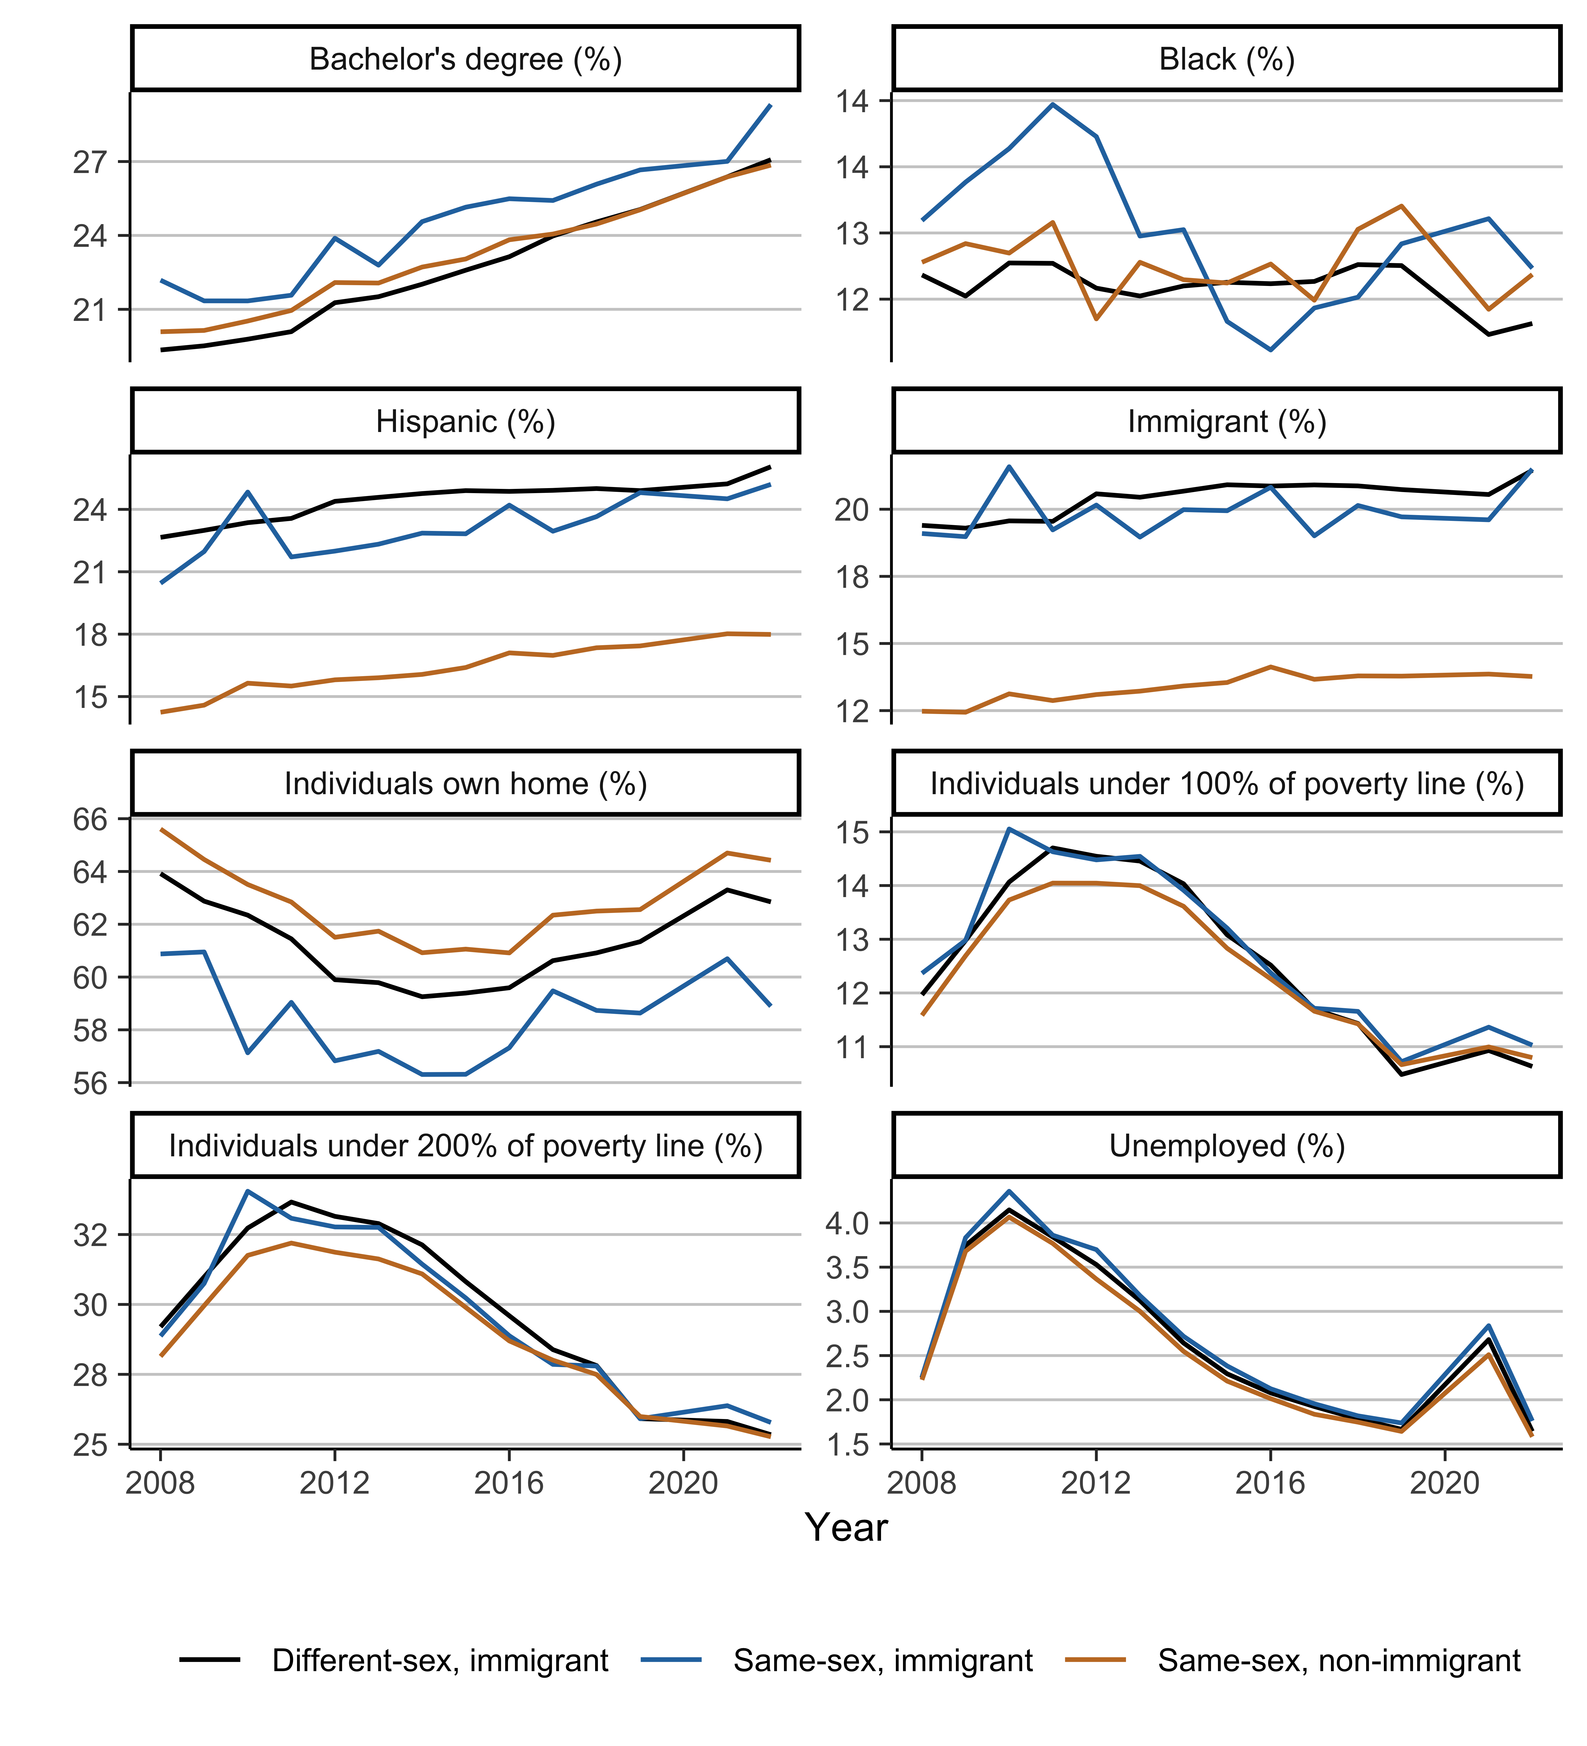

Figure 2: Geographic characteristics (percentages) over time for immigrants in different- and same-sex couples, based on American Community Survey data for 2008-2022

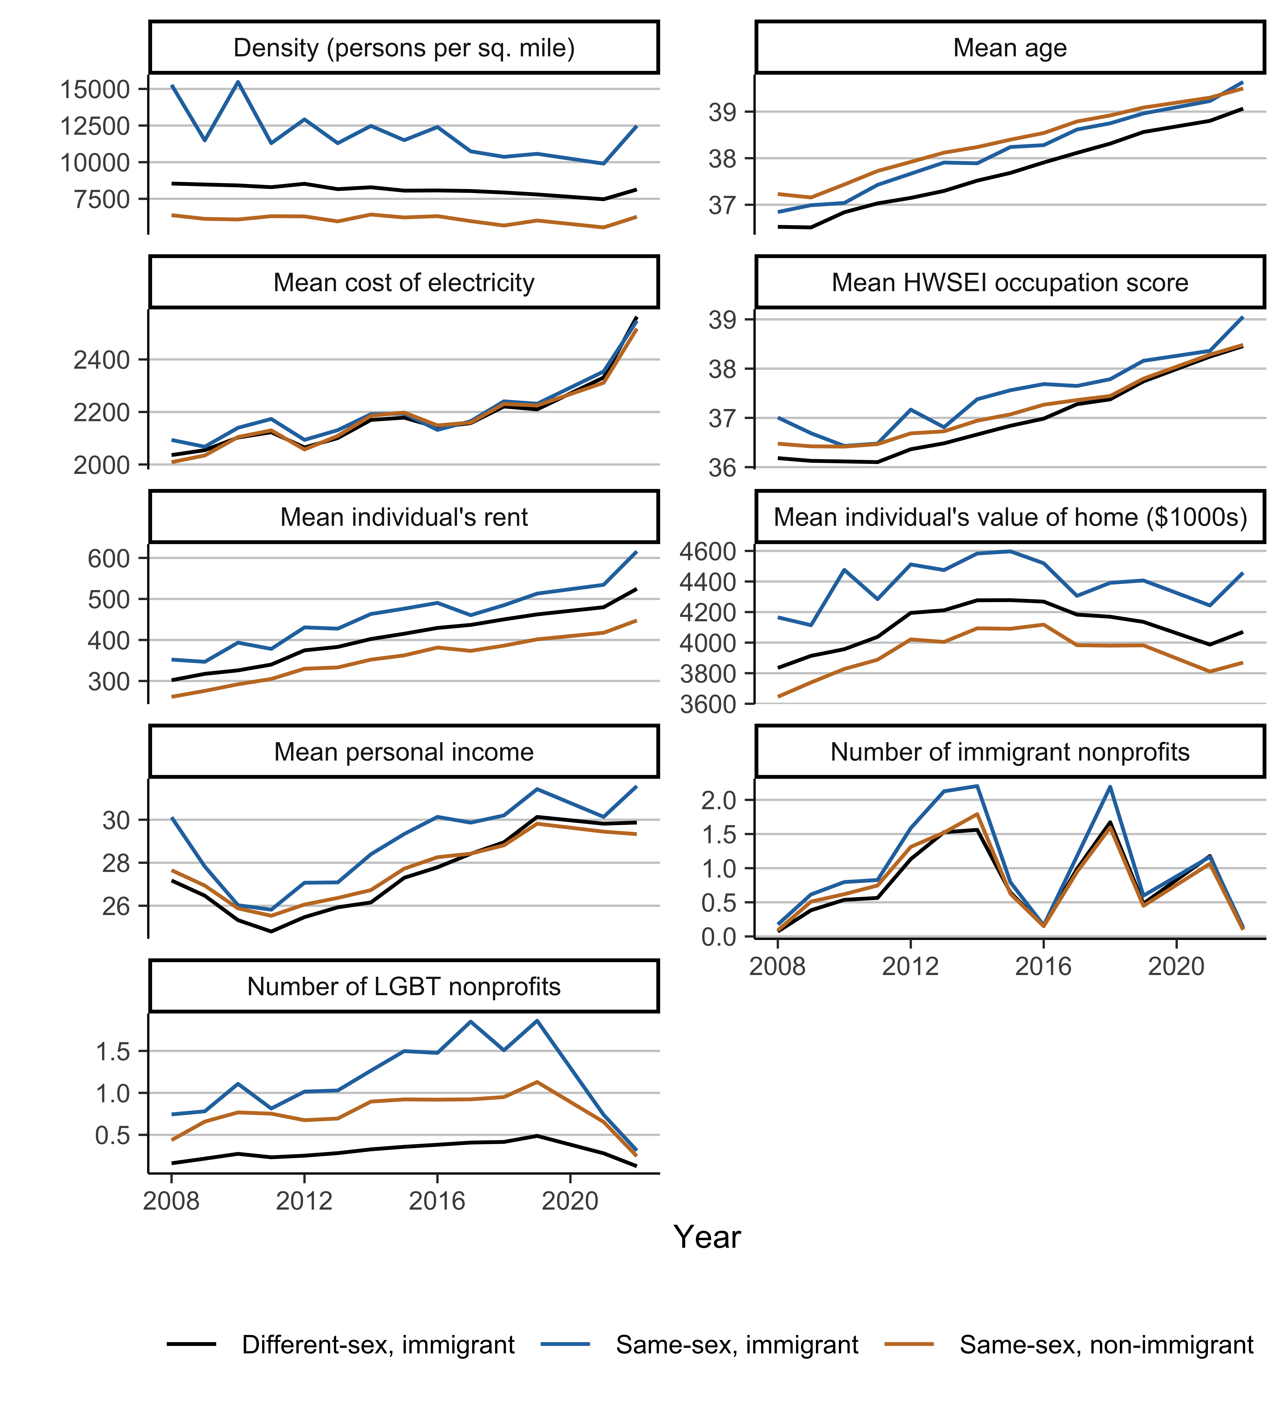

Figure 3: Geographic characteristics (means) over time for immigrants in different- and same-sex couples, based on American Community Survey data for 2008-2022

1. <https://www.lgbtmap.org/>